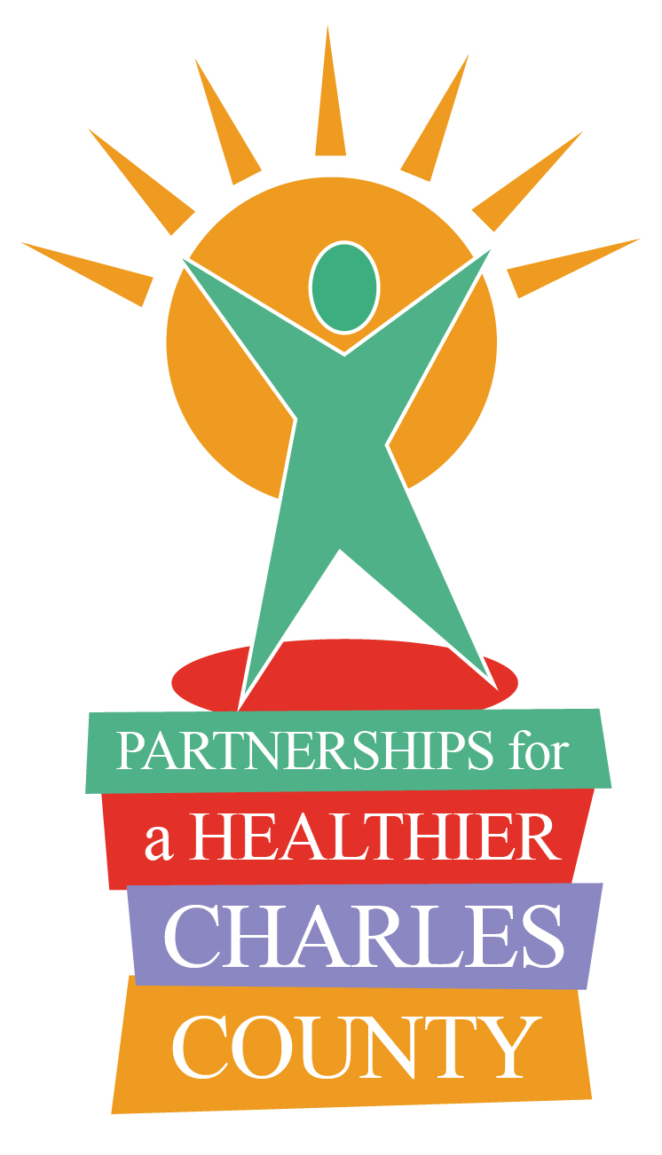
Partnerships for a Healthier Charles County

P.O. Box 1050
White Plains, MD 20695-1050
(301) 609-6901

Agency/Member Information
Update
(September 16, 2020)

Name: Agency:

Phone: Email:

Please note the updates you plan to share at the next PHCC meeting in bullet format below and/or attach a copy if greater detail is necessary. Submit a copy to me by fax/email or prior to the start of the meeting. It is okay to make additions or subtractions during the meeting. Having this sheet will make it easier to capture all points of business and prepare minutes.

Thank you for your assistance and effort in planning.

Program Highlights

►

►

►

Upcoming Events

►

►

►

