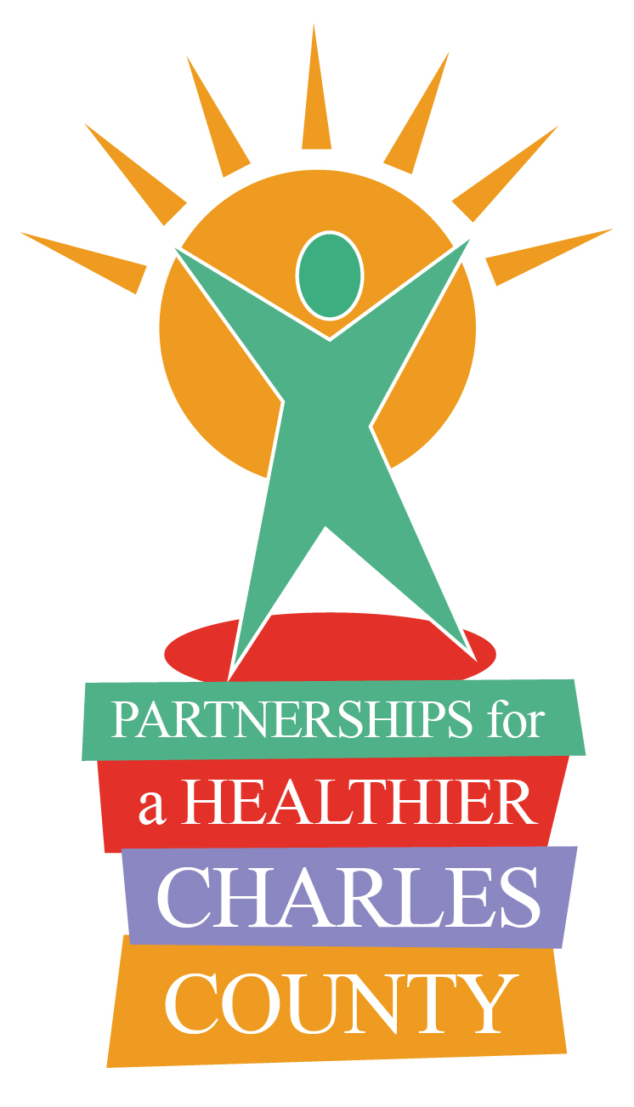
Partnerships for a Healthier Charles County

P.O. Box 1050
White Plains, MD 20695-1050
(301) 609-6901

Membership Application
(please print clearly)

Name First Last

Title

Organization

Address (street & p.o. box)

City State Zip Code

Phone (office)

Cell

Fax

Email

Which PHCC Action Team(s) are you interested in?
 Access to Care | Strategies to improve access to health care services in Charles County
 Behavioral Health | Strategies to address issues concerning mental illness and substance abuse
 Chronic Disease Prevention | Strategies to address issues concerning cancer, heart disease, diabetes, and obesity
Additional Comments/Questions:

